Java based Flight Reservation System Project

Assignment 4

Regis University

MSSE670 – Java Software Development

Spring 2020 Week 4

04/05/2020

Brenda Palmer

Table of Contents

Introduction 3

Purpose 3

Scope 3

Methodology 3

Software Architecture 3

Eclipse Images 5

Eclipse images of Service Layer Classes, Exception Classes and Factory Class 5

Eclipse imager of Service Layer Part 2 JUnit Passing Tests 6

What I Learned 7

# Introduction

The Service Layer is used to take objects from the Domain Layer as inputs of the application where it moves data to and from the database and/or moving data to and from other applications. This week’s assignment begins to focus on the Service Layer implementation which builds upon the Domain Layer.

## Purpose

The purpose of this assignment is to learn how to use self-created exceptions to then declare them in the interface and implementation and then to create corresponding JUnit tests. As well as serializing and deserializing objects to files.

## Scope

This week’s assignment is focused only on creating the exception classes, marker interface, decoupling the Factory class and creating corresponding tests for the factory and implementation classes.

## Methodology

The methodology used for creating the Service Layer Part 2 is UML.

# Software Architecture

The Service Layer Part 2 was created in Eclipse and the following classes where created:

**Interface Classes:** ICustomerAccountService,, ILoginSerive, ISearchFlightInformationService, IListAvailableItineraryOptionsServie, IReserveItinearyServie, IBookItineraryService and IService.

**Implementation Classes:** CustomerAccountImpl, LoginImpl, SearchFlightInformationImpl, ListAvailableItineraryOptionsImpl, ReserveItineraryImpl and BookItineraryImpl.

**Junit Test Classes:** CustomerAccountServiceTest, LoginServiceTest, SearchFlightInformationServiceTest, ListAvailableItineraryOptionsServiceTest, ReserveItineraryServiceTest, BookItineraryServiceTest, FactoryServiceTest, AllServicesTest, CustomerAccountImplTest, LoginImplTest, SearchFlightInformationImplTest, ListAvailableItineraryOptionsImplTest, ReserveItineraryImplTest and BookItineraryImplTest.

**Factory Class:** Factory

**Exception Classes:** InvalidCreditCardException, InvalidLoginException, InvalidSearchFlightException, InvalidOptionsListException, InvalidReserveFlightException, InvalidBookFlightException and ServiceLoadingException.

**FlightDocs:** CreditCardInformation.out, Login.out, SearchFlightInformation.out, OptionsList.out, ReserveFlight.out and BookFlight.out.

**Config:** application.properties

# Eclipse Images

## Eclipse images of Service Layer Classes, Exception Classes and Factory Class

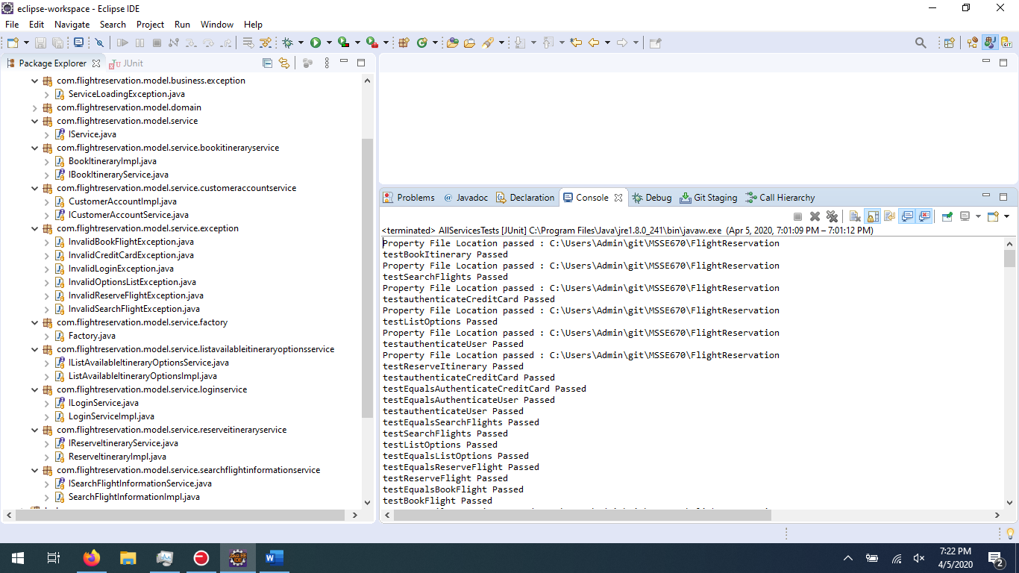Problems tab: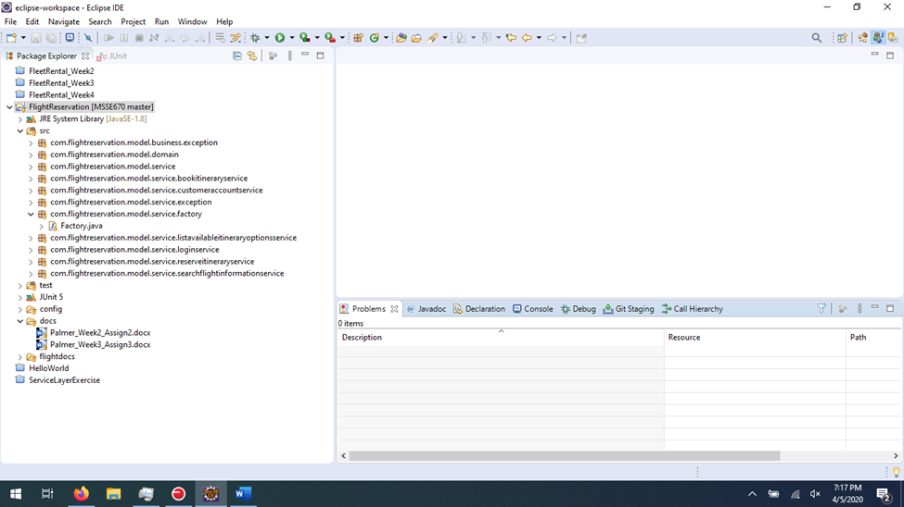

## Eclipse imager of Service Layer Part 2 JUnit Passing Tests

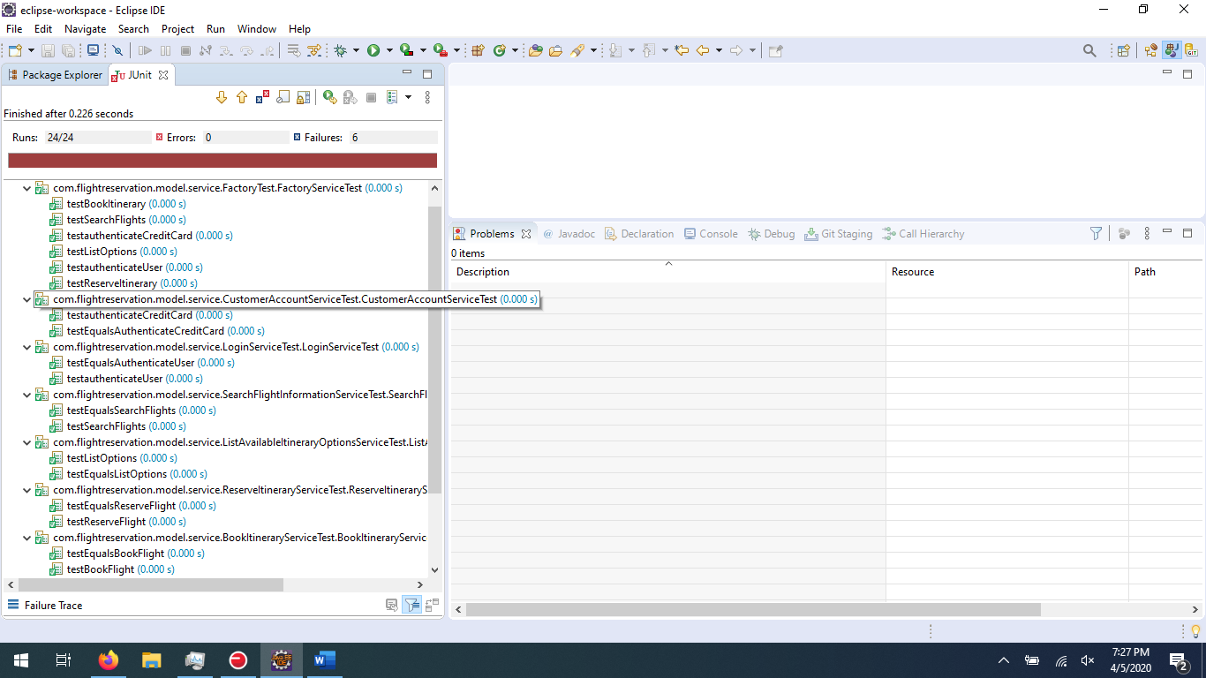

Problems Tab: Same exception is being thrown saying error accessing file. Assumed it was due to an empty file but that didn’t solve the issue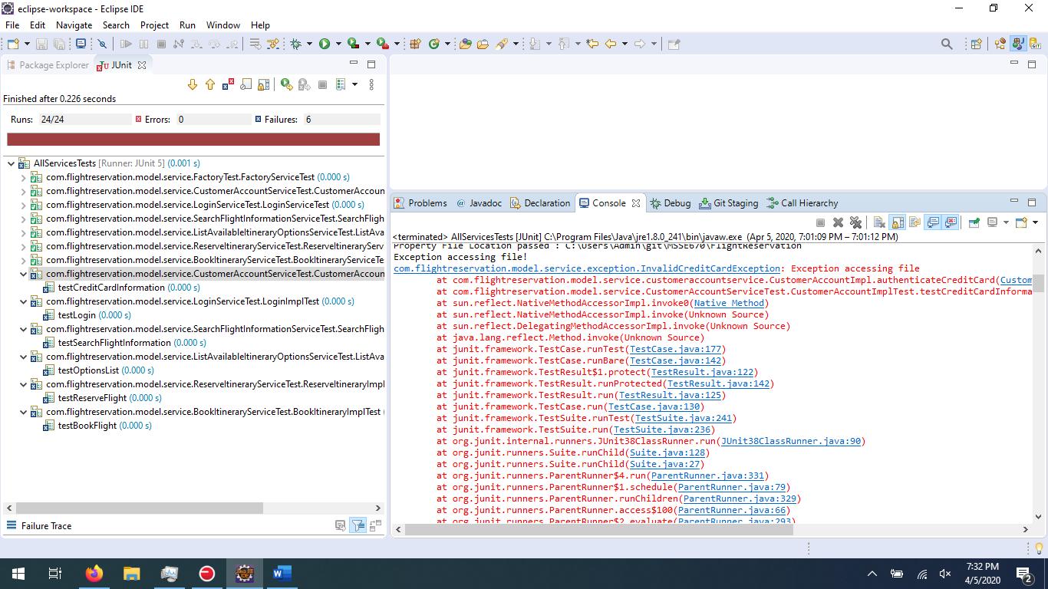

# What I Learned

I learned how to implement exceptions as well as how to create my own exceptions to then implement them. In all of my experience I never heard of a marker interface, so I was able to use this new concept and see how it works in my code. One issue I am having is with an exception being thrown saying error accessing file. Not sure why this is occurring. I wonder if I need to also create a ObjectOutputStream and not just an ObjectInputStream. Going to try this and if I still have time maybe I will get it resolved. This was a challenging assignment, but I do feel I learned a lot.